Contents

CREATE Operation 3

1. Launch URL: http://localhost:8080/tickets 3

2. Verify availability of 'New Ticket' link 4

3. Click on 'New Ticket' link 5

4. Enter details for fields 6

5. Click on 'Submit' 6

READ Operation{5 ma 7

1. Launch URL: http://localhost:8080/tickets 7

2. Click on 'View' for any record in table 8

3. Click on Browser Back arrow 9

UPDATE Operation 10

1. Launch URL: http://localhost:8080/tickets 10

2. Click on 'Edit' for any record in table 11

3. Updated details for fields 12

4. Click on 'Submit' 13

DELETE Operation 14

1. Launch URL: http://localhost:8080/tickets 14

2. Click on 'Delete' for any selected record 15

SEARCH Functionality 16

1. Launch URL: http://localhost:8080/tickets 16

2. Search by Ticket Title 17

3. Click on 'Search' 18

4. Search by Ticket Short Description 19

UI layout 20

1. Check Application URL: http://localhost:8080/tickets 20

2. Click on 'Edit' for any record in table 21

3. Click on 'Submit' 22

4. Select any row and Click on 'Delete' 22

5. Select any row and Click on 'View’, 23

6. Click on Back arrow in Browser and Click on link 'New Ticket' 24

7. Click on 'Submit' 25

8. Enter RITM002 in text box and Click on 'Search' 26

9. Click on 'Tickets' links 27

End of File. 28

# CREATE Operation

## 1. Launch URL: http://localhost:8080/tickets

Ticket Tracking Application page is displayed

Take Screenshot

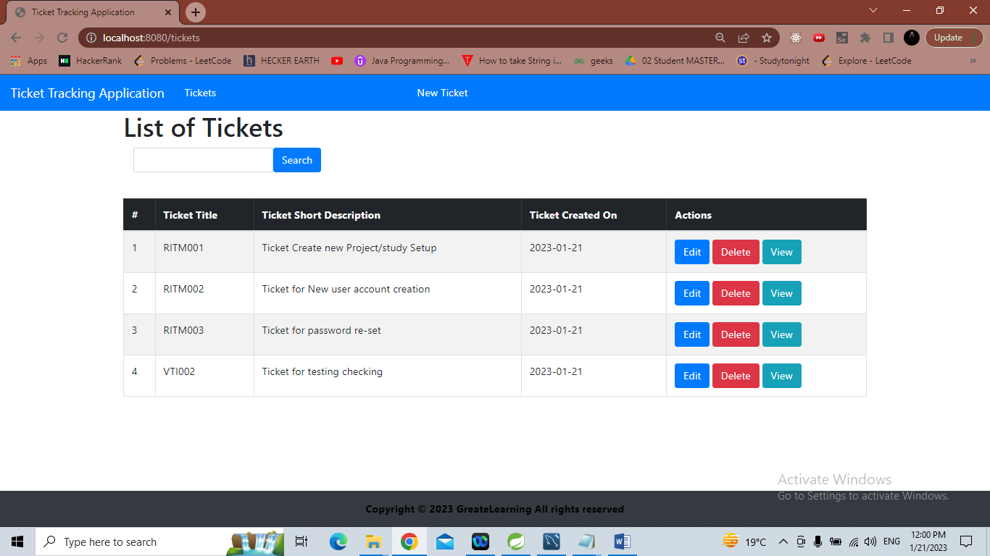

## 2. Verify availability of 'New Ticket' link

Take Screenshot

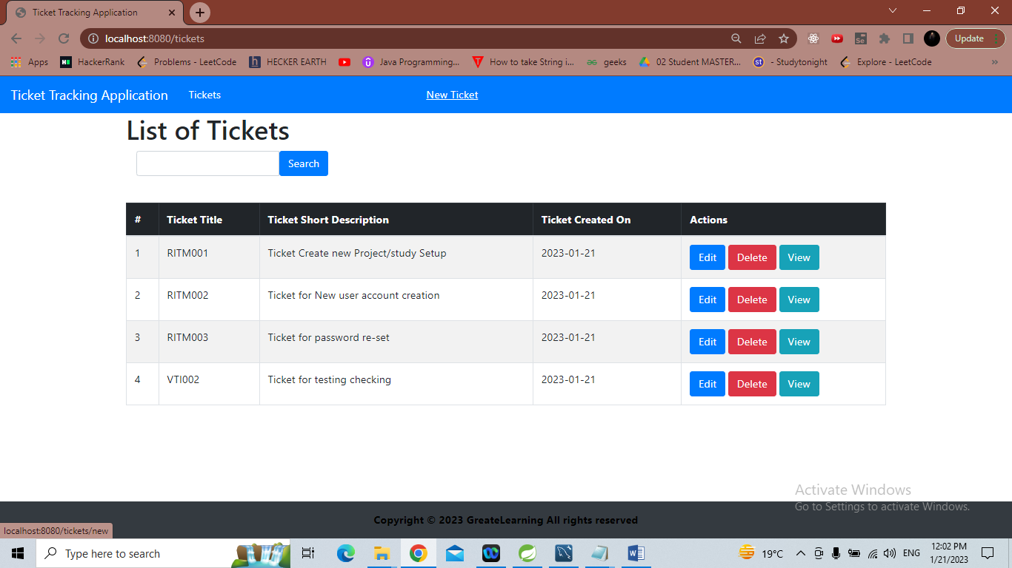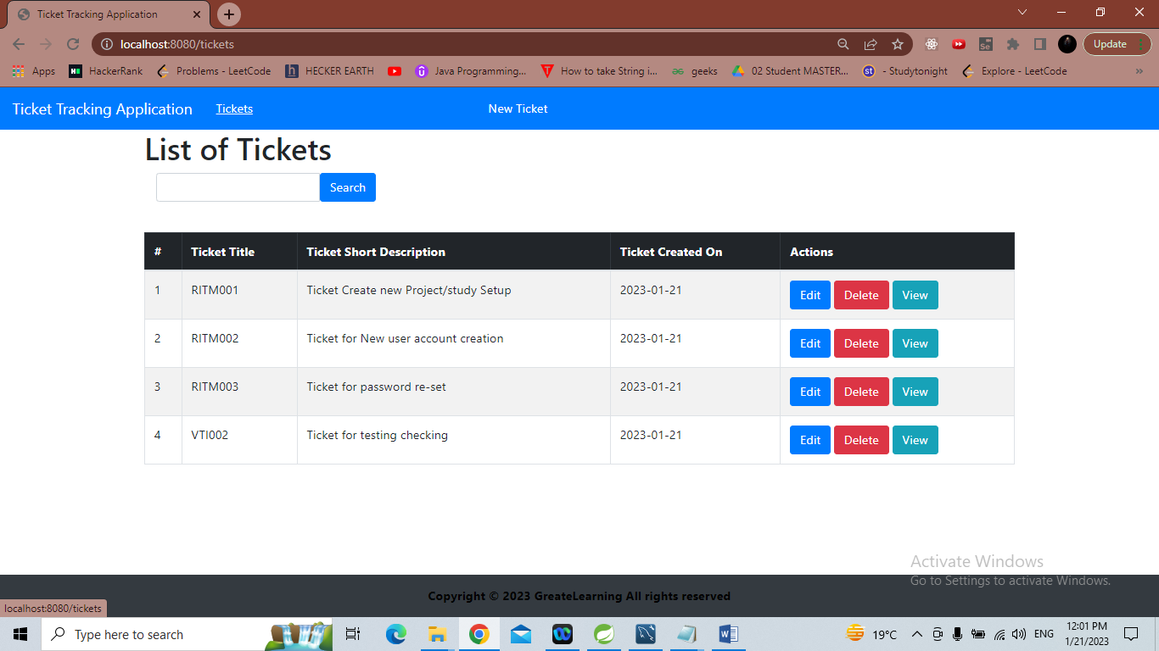

## 3. Click on 'New Ticket' link

Created New Ticket page is displayed

Take Screenshot

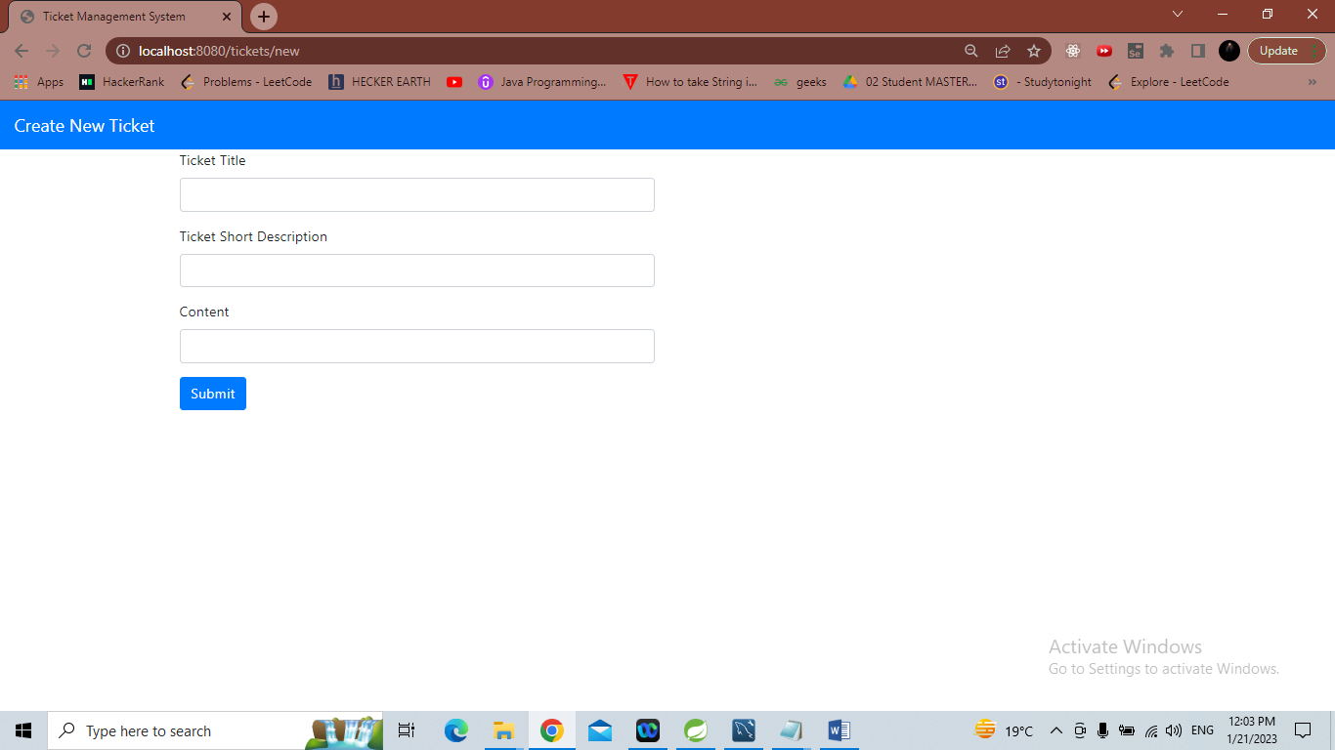

## 4. Enter details for fields

Ticket Title & Ticket Short Description

Take Screenshot

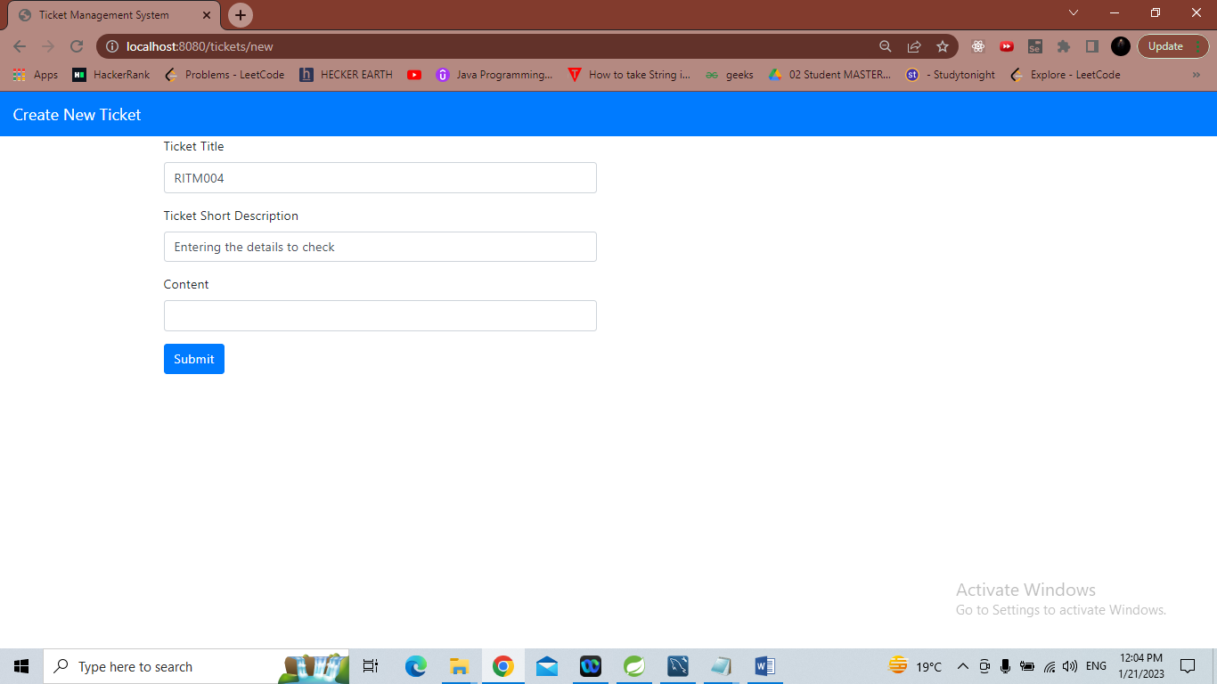

## 5. Click on 'Submit'

Verify new ticket is created with autogenerated # in Ticket Tracking Application page

Take Screenshot

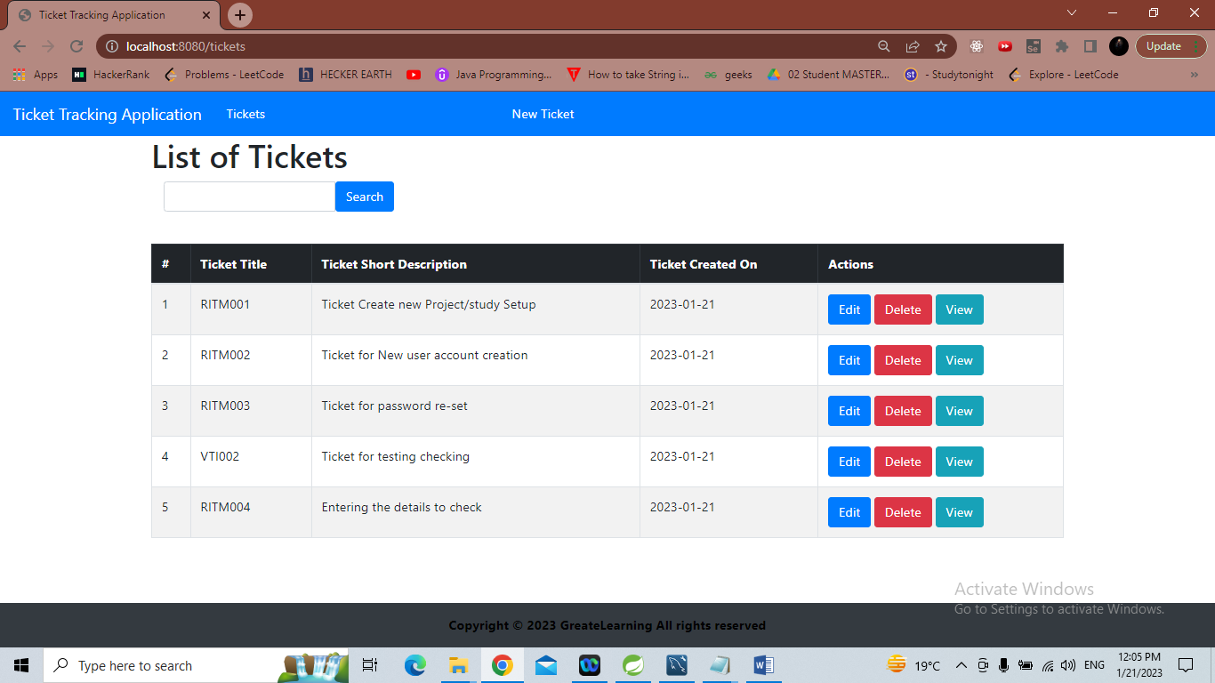

# READ Operation

## 1. Launch URL: http://localhost:8080/tickets

Ticket Tracking Application page is displayed

Take Screenshot

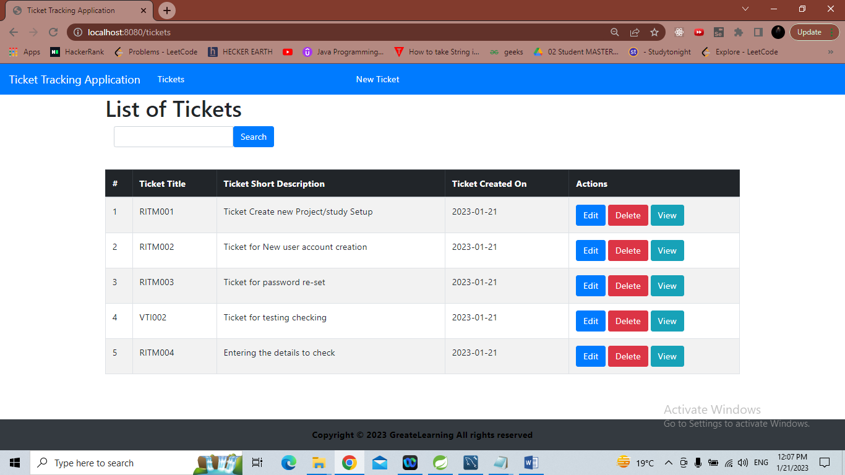

## 2. Click on 'View' for any record in table

Contents of record are shown

Take Screenshot

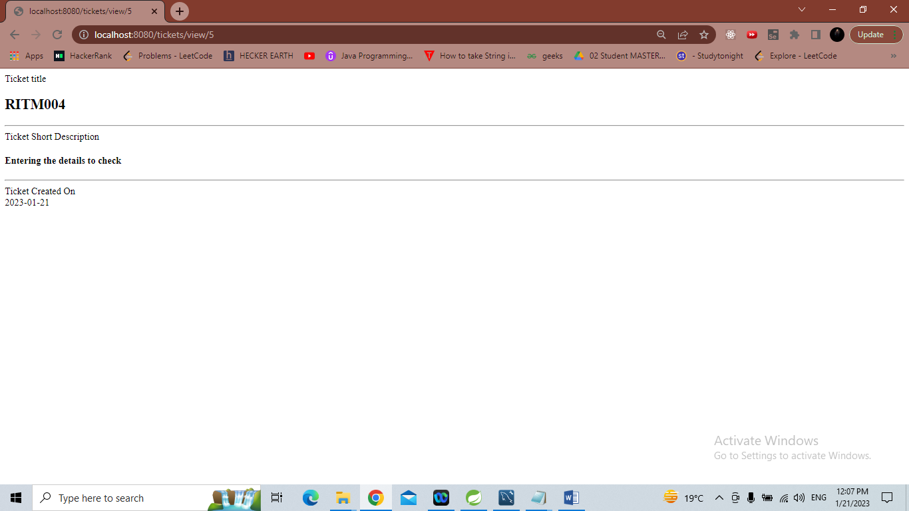

## 3. Click on Browser Back arrow

Ticket Tracking Application page is displayed

Take Screenshot

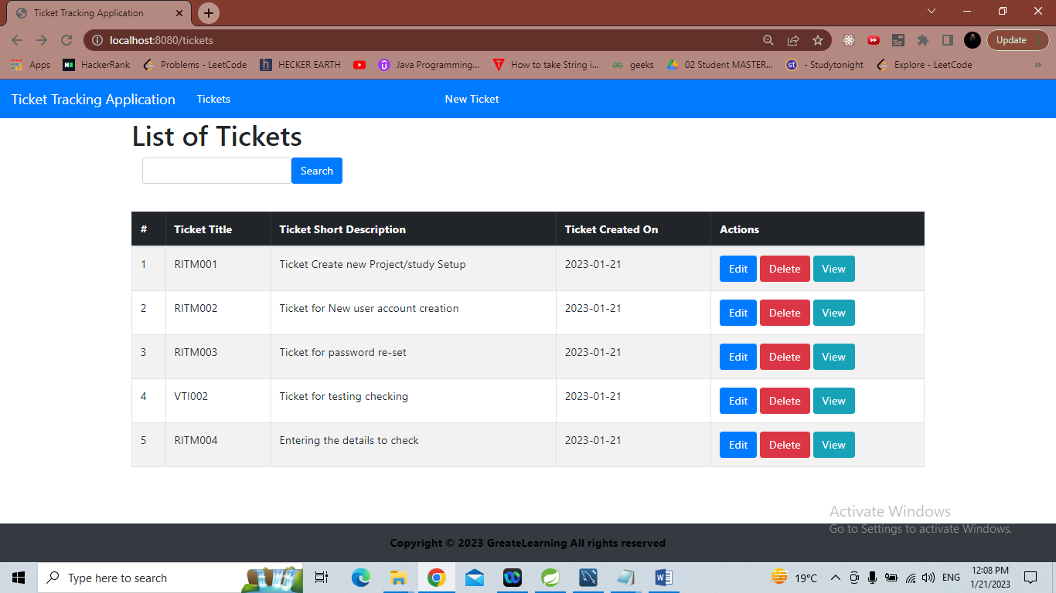

# UPDATE Operation

## 1. Launch URL: http://localhost:8080/tickets

Ticket Tracking Application page is displayed

Take Screenshot

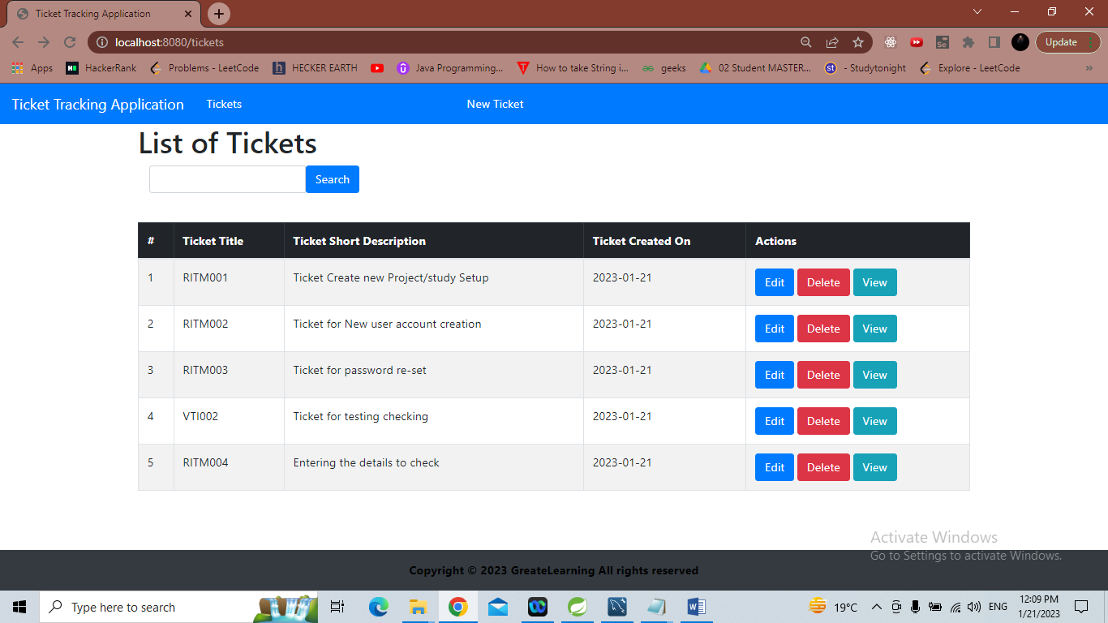

## 2. Click on 'Edit' for any record in table

Edit Ticket page is displayed

Take Screenshot

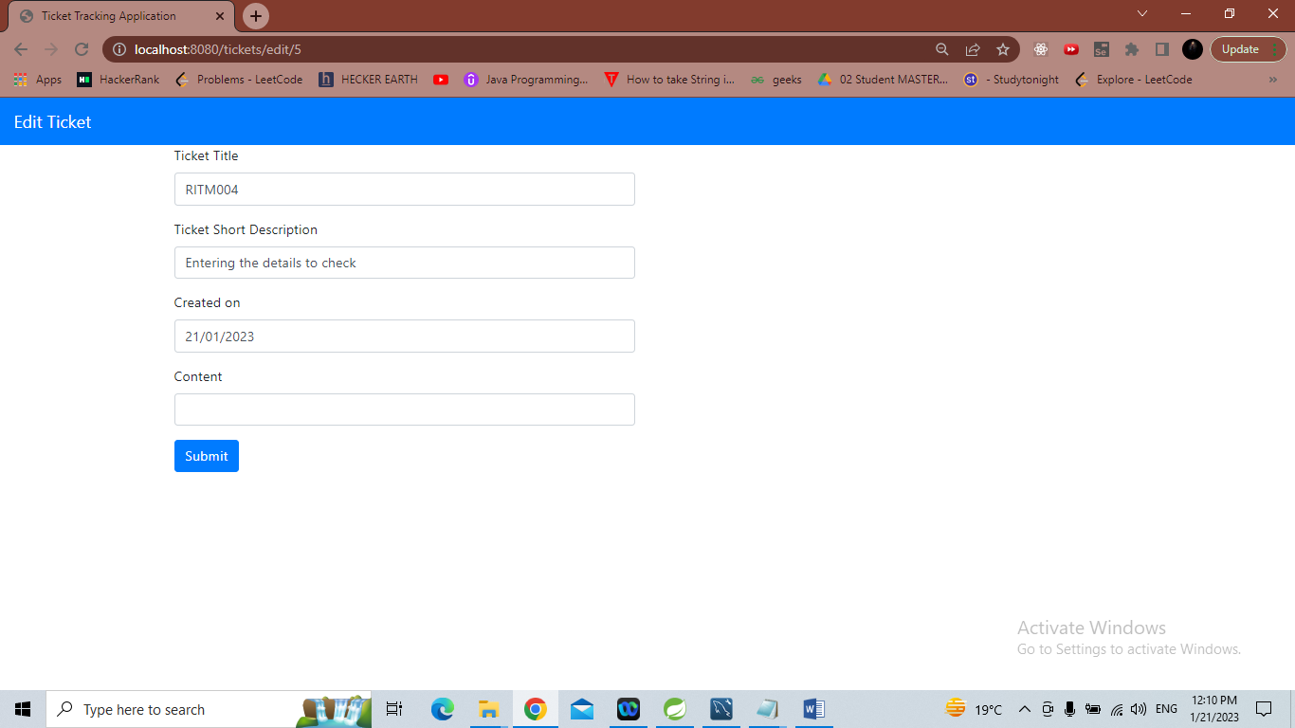

## 3. Updated details for fields

Ticket Title, Ticket Short Description

Take Screenshot

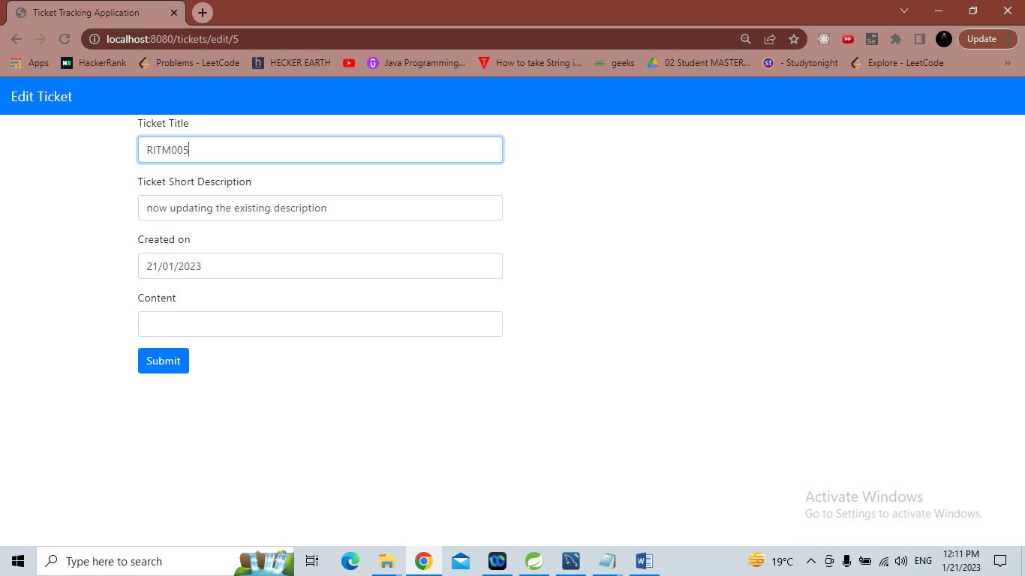

## 4. Click on 'Submit'

Verify updated are show in Ticket Tracking Application page

Take Screenshot

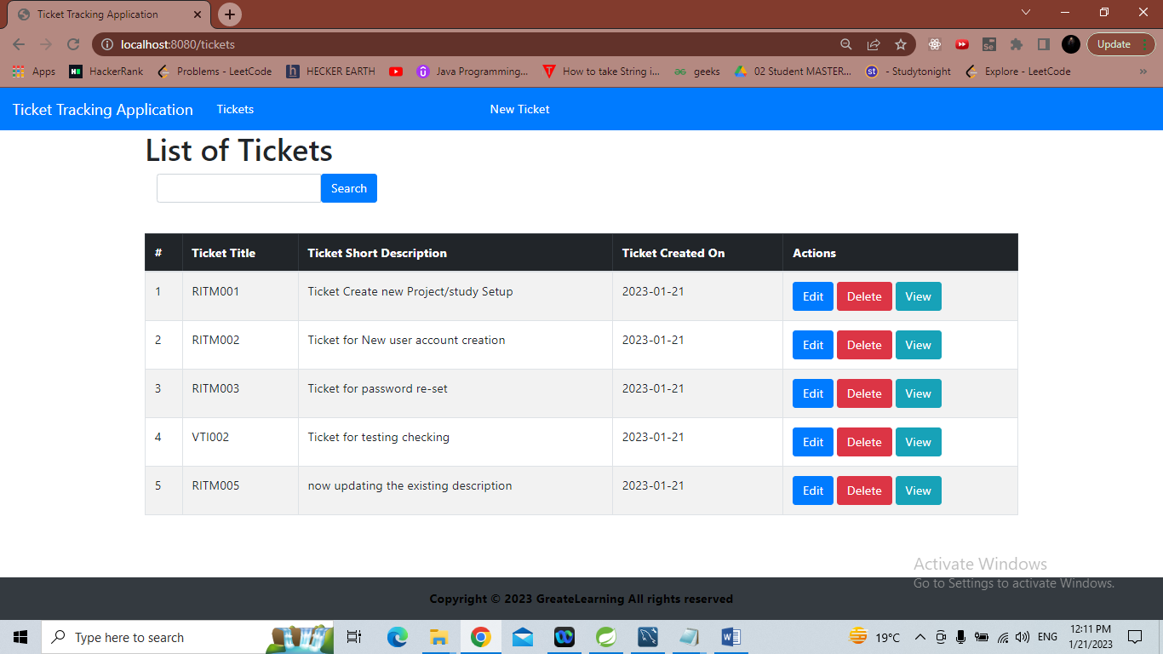

# DELETE Operation

## 1. Launch URL: http://localhost:8080/tickets

Ticket Tracking Application page is displayed

Take Screenshot

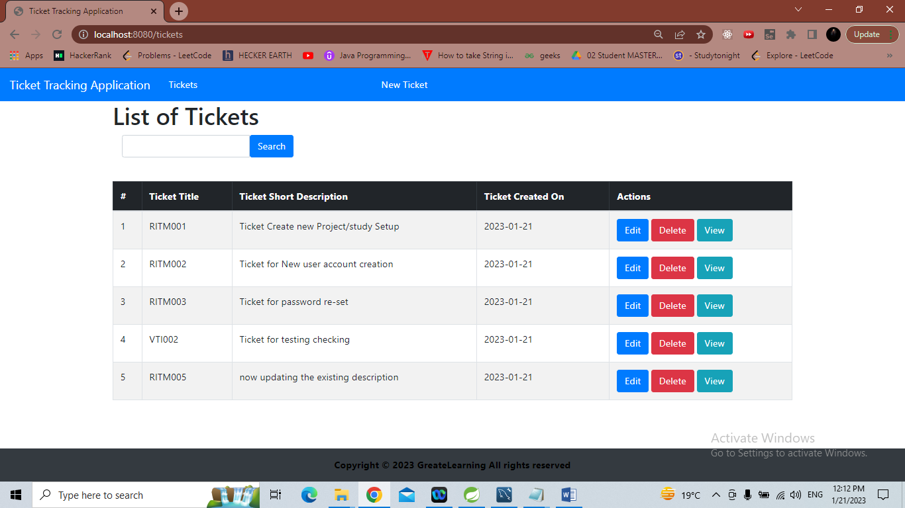

## 2. Click on 'Delete' for any selected record

Verify record is not available in Ticket Tracking Application page

Take Screenshot

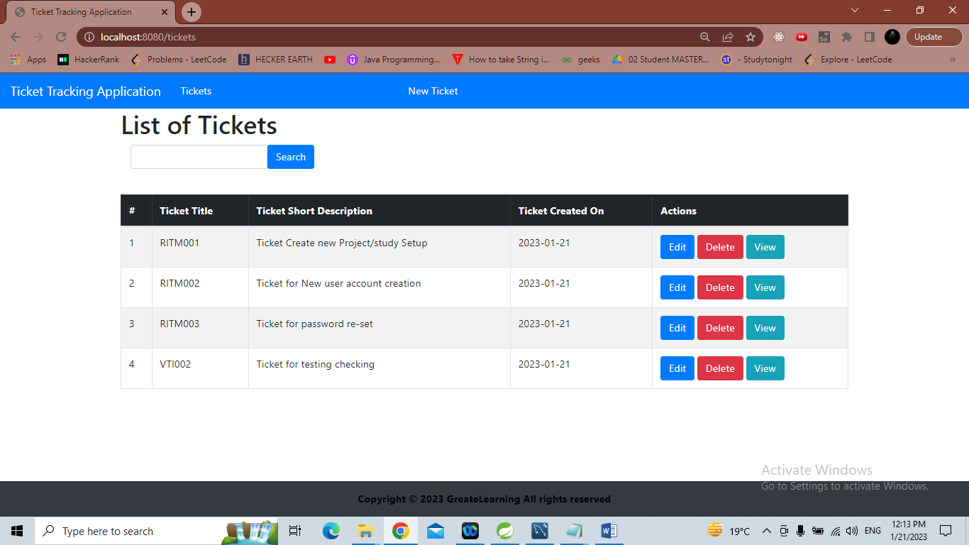

# SEARCH Functionality

## 1. Launch URL: http://localhost:8080/tickets

Ticket Tracking Application page is displayed

Take Screenshot

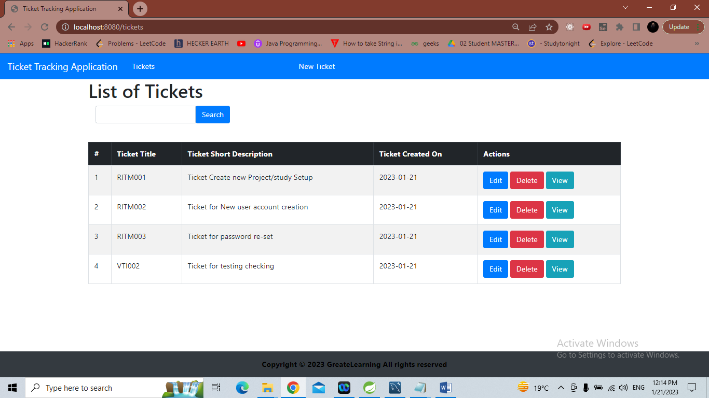

## 2. Search by Ticket Title

Enter Ticket Title as - RITM003

Take Screenshot

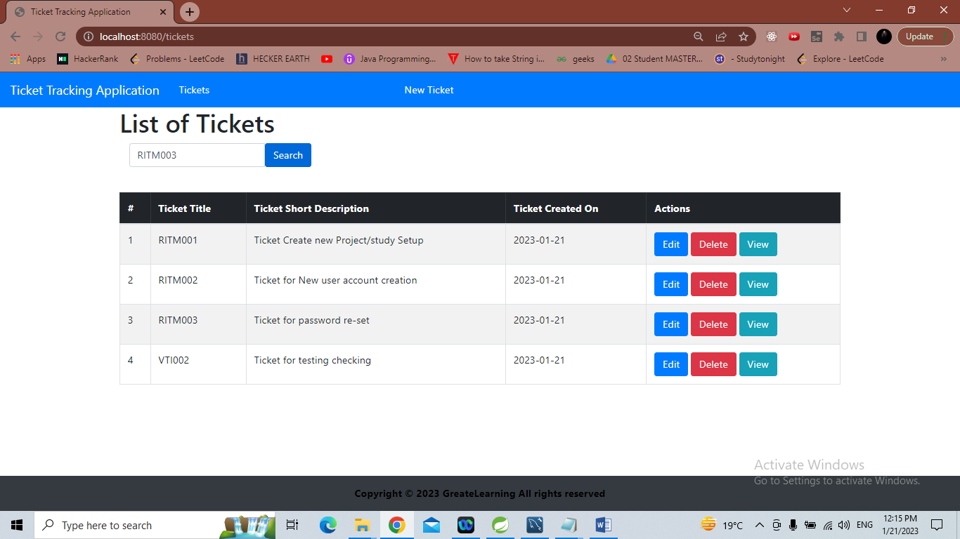

## 3. Click on 'Search'

Verify search results with matching criteria are displayed in Ticket Tracking Application page

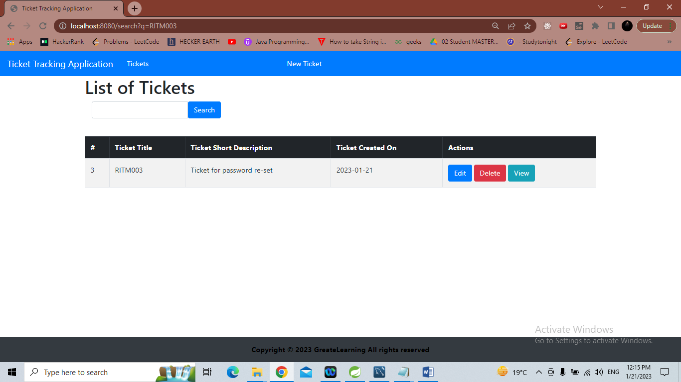

## 4. Search by Ticket Short Description

Enter Ticket Title as - account

Verify search results with matching criteria are displayed in Ticket Tracking Application page

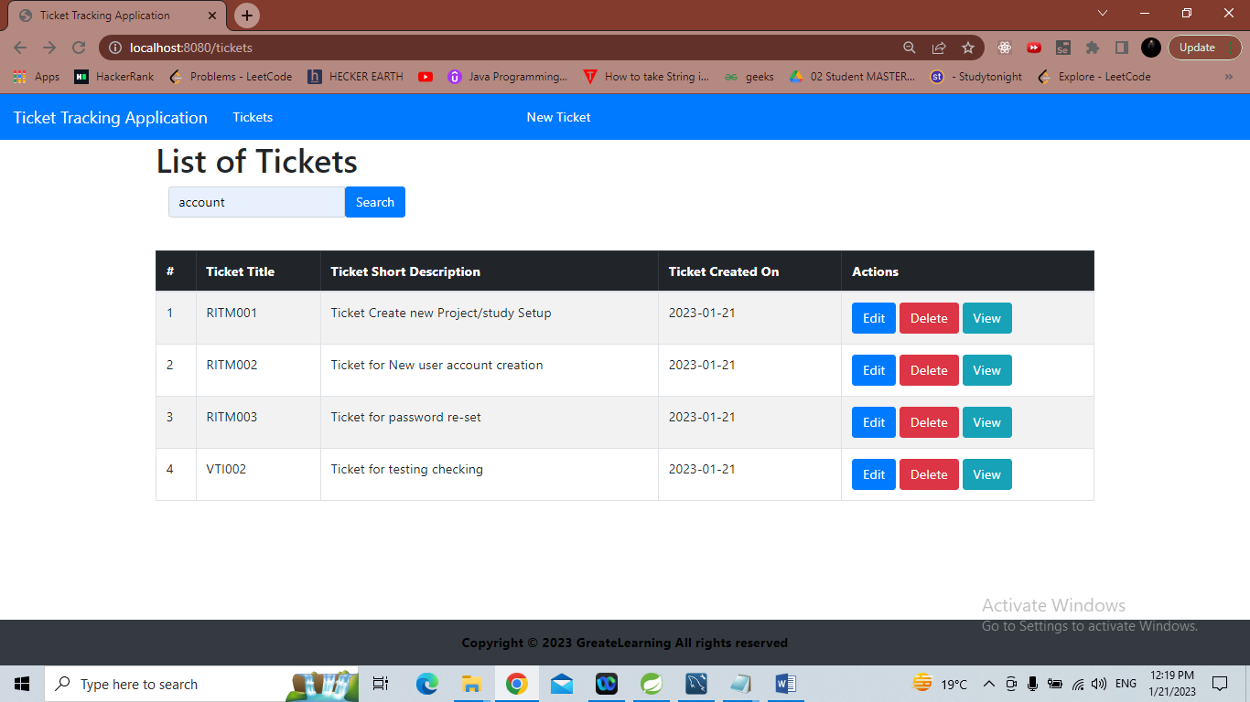

Result of search

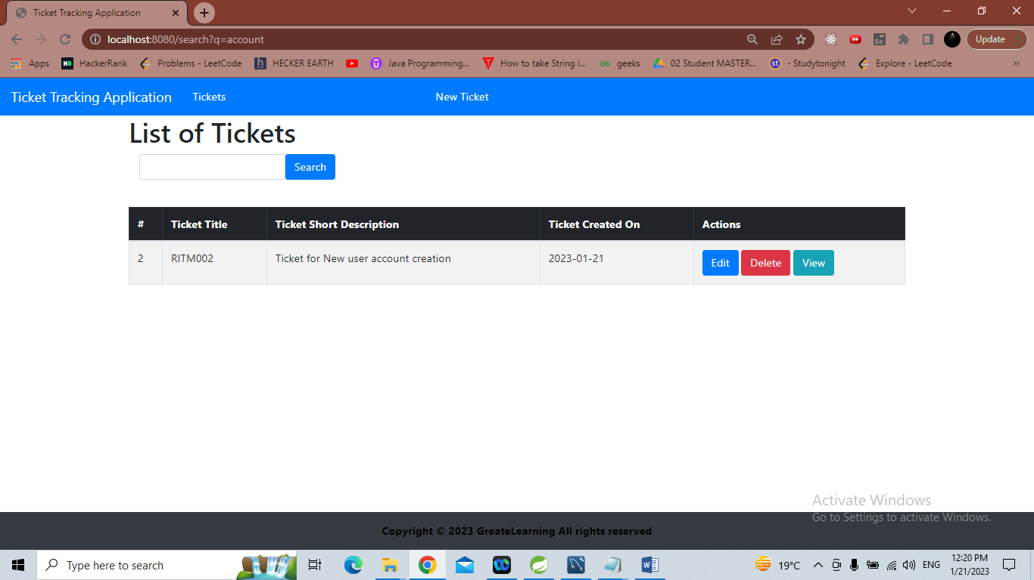

# UI layout

## 1. Check Application URL: http://localhost:8080/tickets

Home Screen (i.e., Ticket Tracking Application page) with data and action buttons (Tickets, New Ticket, Edit, Delete, View) is displayed

Take Screenshot

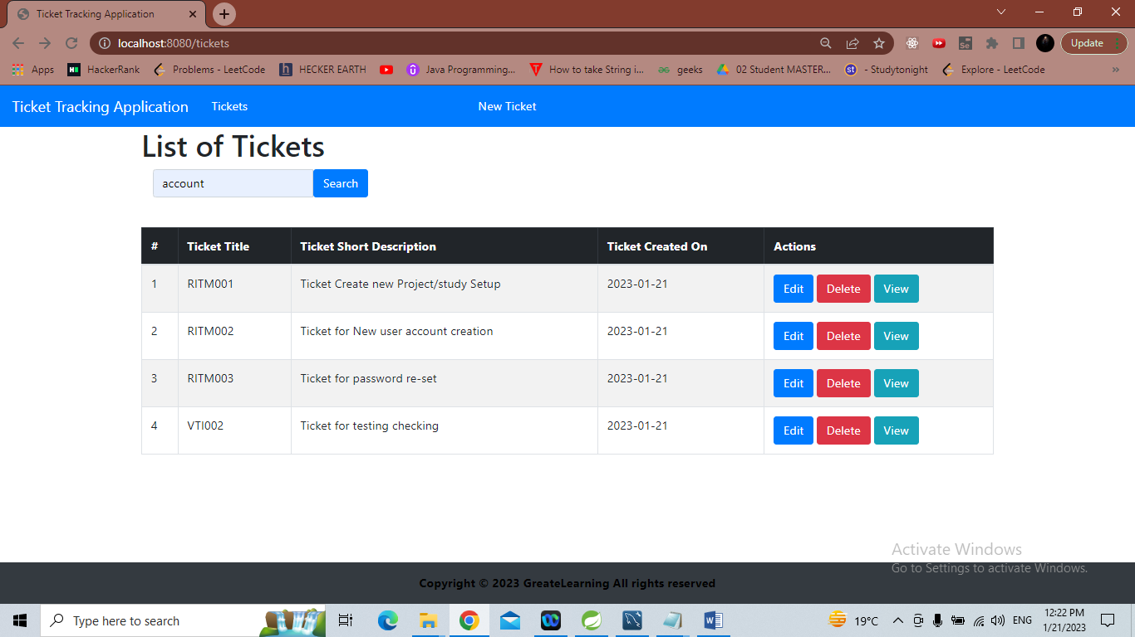

## 2. Click on 'Edit' for any record in table

Edit Ticket page is displayed

Take Screenshot

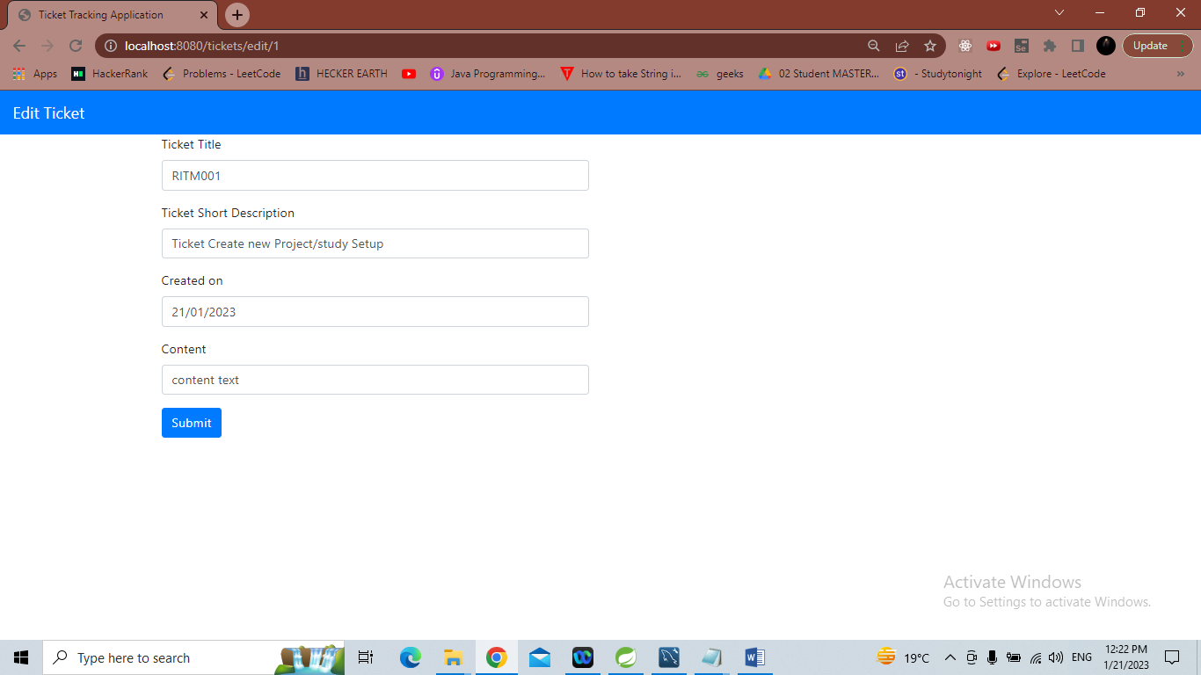

## 3. Click on 'Submit'

Ticket Tracking Application page is displayed

Take Screenshot

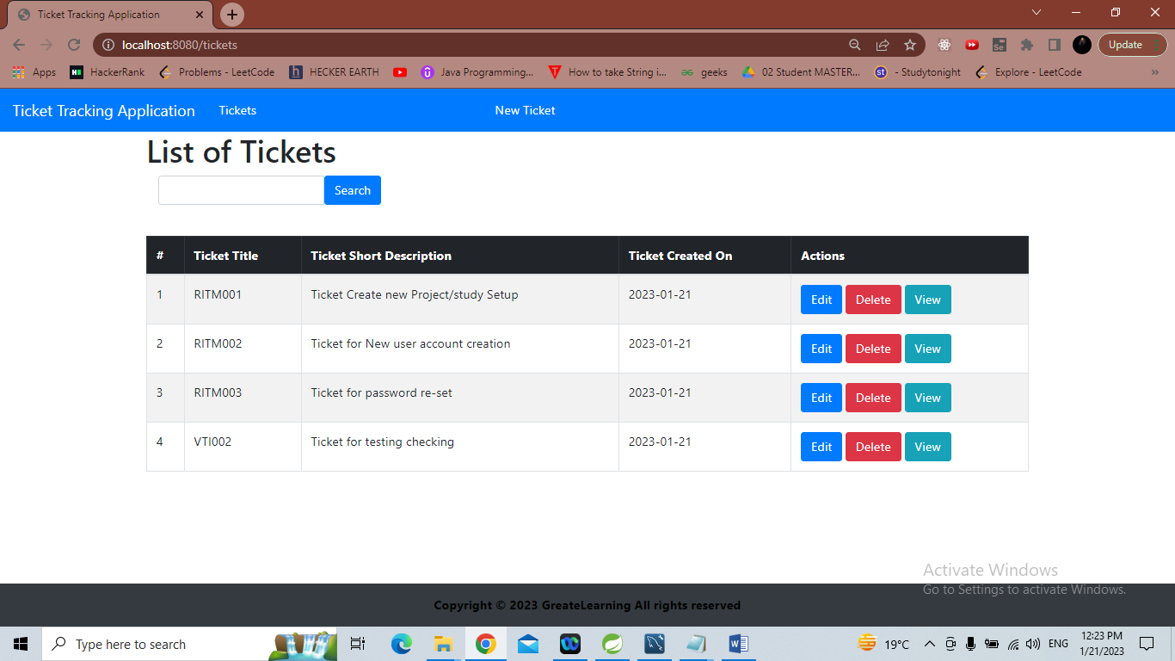

## 4. Select any row and Click on 'Delete'

Selected row deleted and Ticket Tracking Application page is displayed

Take Screenshot

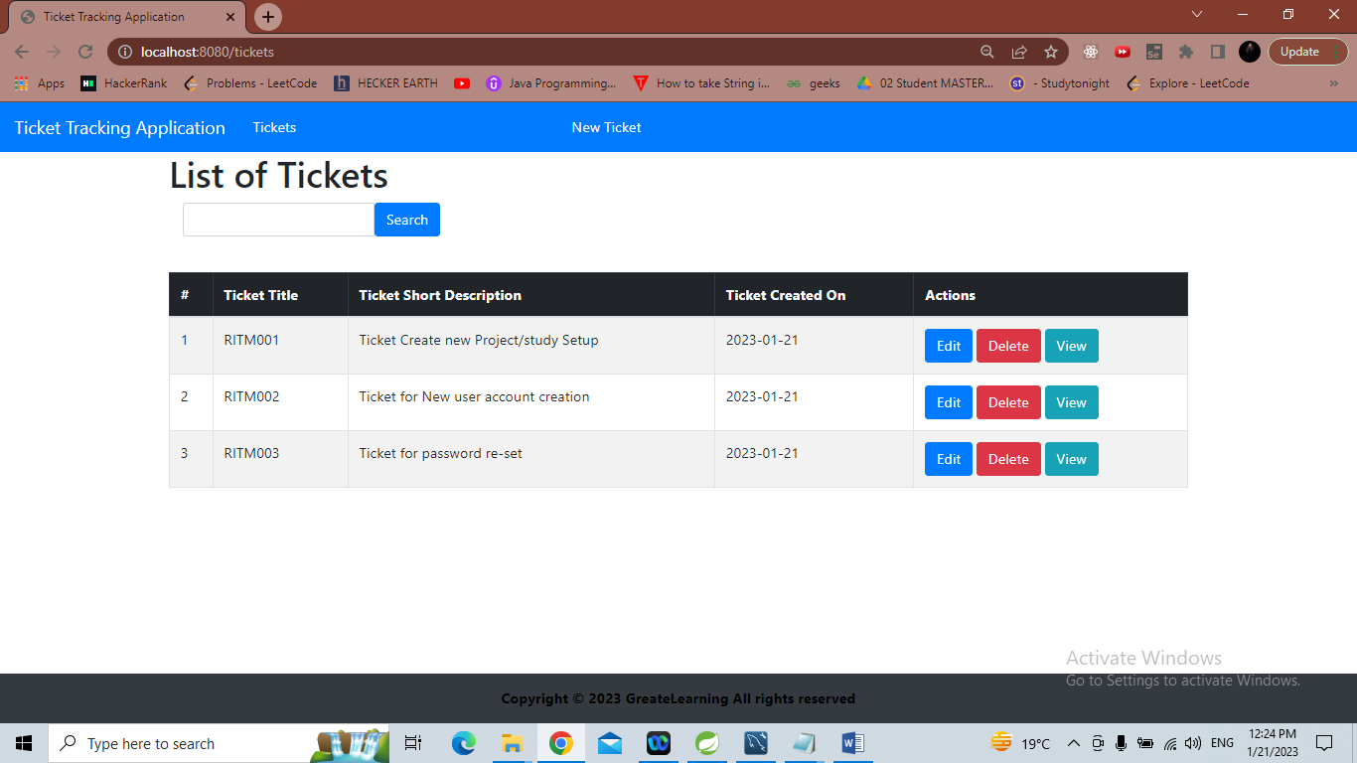

## 5. Select any row and Click on 'View’,

URL path : http://localhost:8080/tickets/view/{id} and Record details are shown

Take Screenshot

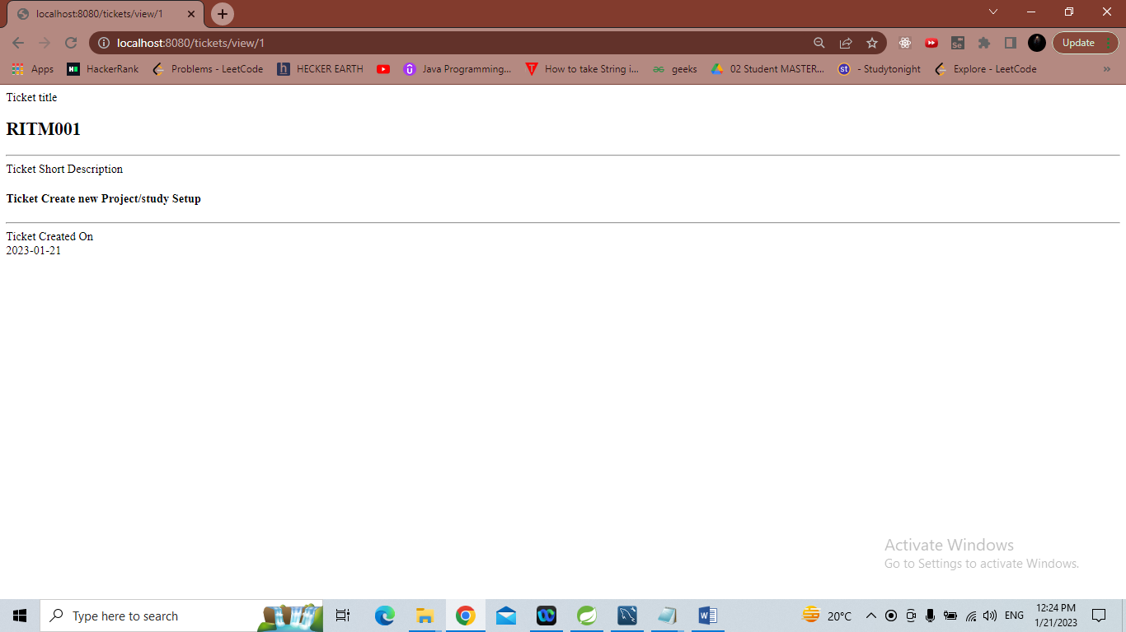

## 6. Click on Back arrow in Browser and Click on link 'New Ticket'

Create New Ticket page is displayed

Enter Title as 'RITM002'

//entering RITM004 as the RITM002 already exists.

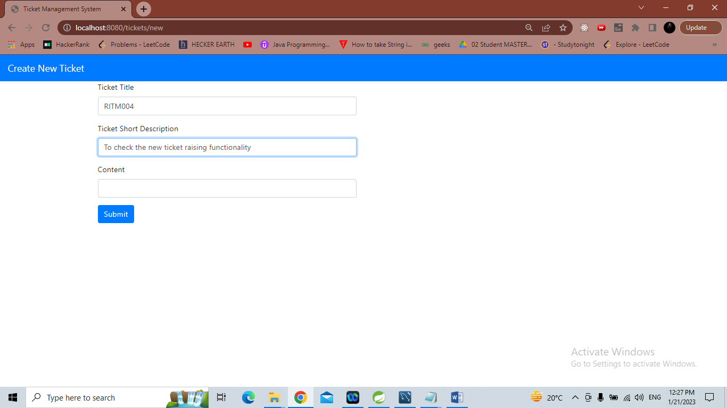

## 7. Click on 'Submit'

Ticket Tracking Application page is displayed

Take Screenshot

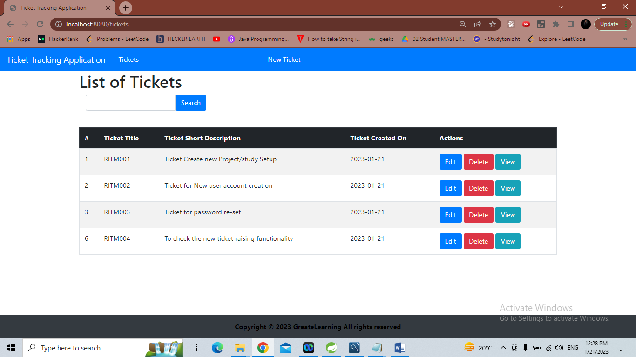

## 8. Enter RITM002 in text box and Click on 'Search'

Search results are displayed as per search condition

Take Screenshot

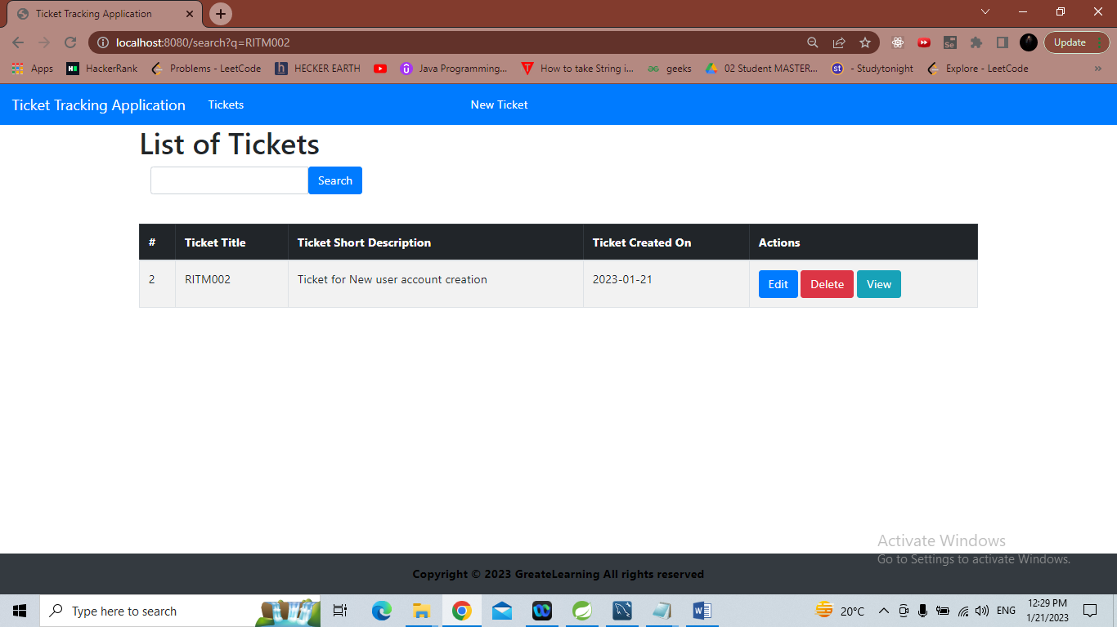

## 9. Click on 'Tickets' links

Ticket Tracking Application page is displayed with all records

Take Screenshot

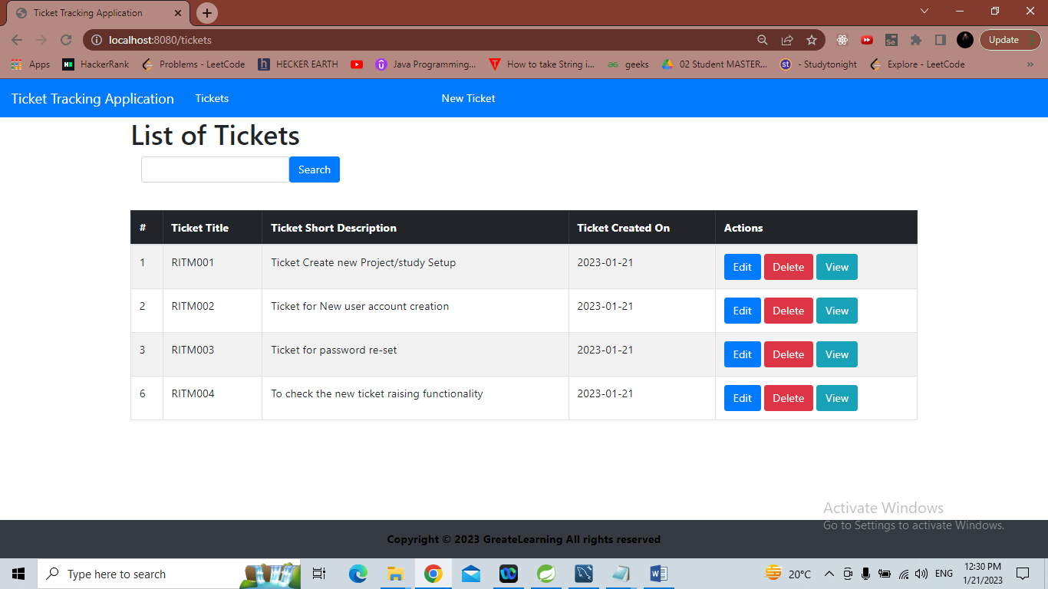

# End of File.